

**Khulna University of Engineering and Technology,Khulna(KUET)**

Report on Automatic Railway Gate Controlling and Track Monitoring

Supervisor :

Prof. Dr. Md. Shariful Islam

Professor,Dept. of ECE,KUET

Submitted By :  
R.M. Rejaur Rahim( 1409013)  
Tahsin Ahmed Khan(1409027)

Date of Submission : 11-12-2017

**Introduction:**

Automatic Railway Gate Control System is a simple but very useful project, which help is automatically opening and closing the railway gate upon detecting arrival or departure of the train.In general, Railway gates are opened or closed manually by a gate keeper. The information about arrival of train for opening or closing of door is received from nearby station. But some railway crossings are totally unmanned and many railway accidents occur at these unmanned level crossings.To avoid the human intervention at level crossings completely, we need to automate the process of railway gate control.

**Principle of Operation :**

The principle of operation behind the working of this project lies in the functioning of IR Sensor. A Reflective type IR Sensor is used in this project. In Reflective Type IR Sensor, the IR transmitter and receiver are placed side by side. When there is no obstacle in front of the sensor, the IR rays transmitted by the IR Transmitter will travel undetected as there are no rays falling on the IR Receiver. If there is an obstacle in front of the IR Transmitter and Receiver pair, the IR Rays gets reflected off from the surface of the obstacle and are incident on the IR Receiver. This setup can be configured to detect an object like a Train and in turn can be used to switch ON or OFF the loads like motors with the help of microcontroller.

#### **Project Components :**

* Arduino Uno
* Arduino Mega 2560
* Obstacle IR Sensors
* Servo Motor
* DC Gear Motor
* Ultrasonic Sound Sensor
* GSM Module etc

#### **Component Description :**

**IR Sensor:**

An IR sensor is used in this project to sense the arrival and departure of the train. An IR Sensor generally comprises of two components: an IR Transmitter and an IR Receiver. An IR Transmitter is a device that emits IR Rays. Similarly an IR Receiver is a device that detects the IR Rays. Photo Diodes are the most commonly used IR Receivers.

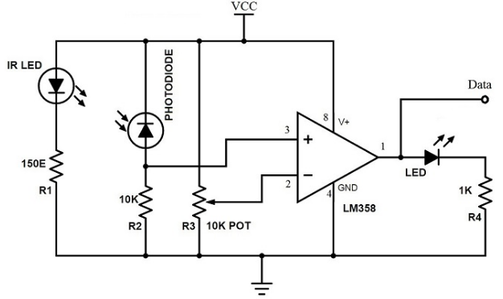

Fig 1.1:  circuit of IR Sensor

**Arduino:**

Arduino is an open-source platform used for building electronics projects. Arduino consists of both a physical programmable circuit board (often referred to as a microcontroller) and a piece of software, or IDE (Integrated Development Environment) that runs on your computer, used to write and upload computer code to the physical board. The Arduino platform has become quite popular with people just starting out with electronics, and for good reason. Unlike most previous programmable circuit boards, the Arduino does not need a separate piece of hardware (called a programmer) in order to load new code onto the board – you can simply use a USB cable. Additionally, the Arduino IDE uses a simplified version of C++, making it easier to learn to program. Finally, Arduino provides a standard form factor that breaks out the functions of the micro-controller into a more accessible package.

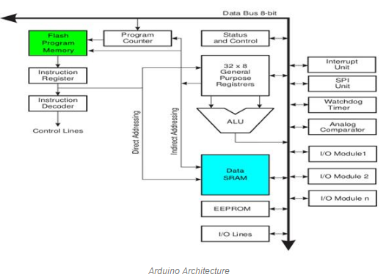

Fig 1.2 : Block Diagram of Arduino

**ServoMotor:**A servomotor is a rotary actuator or linear actuator that allows for precise control of angular or linear position, velocity and acceleration .It consists of a suitable motor coupled to a sensor for position feedback. It also requires a relatively sophisticated controller, often a dedicated module designed specifically for use with servomotors. The motor is paired with some type of encoder to provide position and speed feedback. In the simplest case, only the position is measured. The measured position of the output is compared to the command position, the external input to the controller. If the output position differs from that required, an error signal is generated which then causes the motor to rotate in either direction, as needed to bring the output shaft to the appropriate position. As the positions approach, the error signal reduces to zero and the motor stops. The very simplest servomotors use position-only sensing via a potentiometer and bang-bang control of their motor; the motor always rotates at full speed (or is stopped). This type of servomotor is not widely used in industrial motion control, but it forms the basis of the simple and cheap servos used for radio-controlled models.

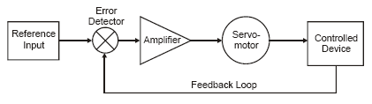

Fig 1.3: Block Diagram of a Servo Motor

**Working Principle:**

**Automatic Railway Gate Controller:**

Practically, the two IR sensors are placed at left and right side of the railway gate. The distance between the two IR sensors is dependent on the length of the train. In general we have to consider the longest train in that route.

Now we’ll see how this circuit actually works in real time. In this image, we can see the real time representation of this project.  
  
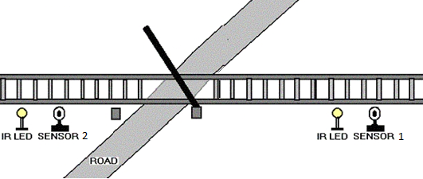

Fig 1.4: When train is not arriving,gate opened.

* If the sensor 1 detects the arrival of the train, microcontroller starts the motor with the help of motor driver in order to close the gate.
* The gate remains closed as the train passes the crossing.

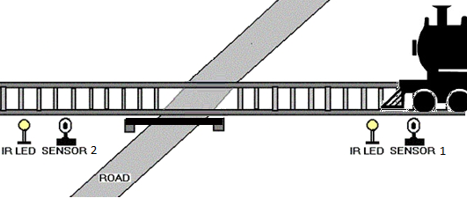

Fig 1.5: When train is coming,gate closed.

* When the train crosses the gate and reaches second sensor, it detects the train and the microcontroller will open the gate.

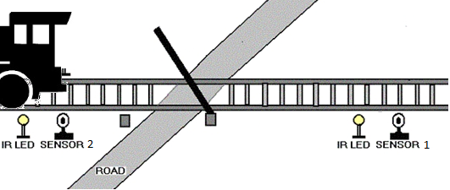

Fig 1.6: When train crosses 2nd sensor,gate again opened.

**Speed Measurement on a turn of the track:**

* For this,we use two ir sensors keeping distance between 16cm.That is our predefined distance.
* When the train cross the ir1,it senses the train and given us a time period.The same thing is done for ir2,it also gives us another time period.
* Then,calculate the difference between two time period.
* Now,we have two values,distance,time.By using v=s/t,we calculate the velocity of the train.
* The velocity of a turn of the track is calculated by tanx = v^2/rg.
* If the the speed of the train is greater than the speed of the turn,it alerts the train driver to reduce the speed.

**Track Monitoring Robot:**

* This robot is used to check the track.Here,one sonar sensor,two ir sensors,and gsm module are used.
* Sonar sensor is used to detect whether any obstacle or object is in the track which causes problem to the train.It detects it,send a message to the authority to remove it quickly.
* Two ir sensors are used to find out the fault of the track.Suppose,if the slipper of the track is opened,it detects it,and sends a message to the authority using GSM module.For this,we use AI thinker A7 gsm+gprs module.

**Limitations:**

We try our best to do this project successfully.But we have some limitations.

1.In case of automatic railway gate controller,the ir sensors just detect the object.But,they don’t detect whether it is train or any object like,human,animal etc.

2.In case of speed measurement,sometimes,the value of the velocity is not correct.

3.In case of track monitoring robot,the sonar sensor doesn’t detect whether the object is moving or not.The ir sensors just detect the placement of the slipper on the track.It doesn’t detect critical damage of the railway track.

4.The strength of the GSM module antenna is not good at all.For this,somtime,the message cannot send properly.

**Future Works:**

In future,at first we try to solve our limitations so that the devices can give us expected result which we always want.To solve all the limitations which are discussed before,we use Image Processing.By using image processing,the device can easily differ between the train and the other objects.Image processing also helps us to find out the critical problems of the railway track and also determine the speed of the train.

Our next plan is to add gps system to find out the location where the problem is detected.It helps the authority go there quickly and solve the problem.

**Discussion:**

For considering the cost of this project,we use cheap equipment like ir sensor,ultrasonic sensor,gsm module,arduino.For this, we have some limitations which are discussed before.We will try to solve the limitations in future.For this,we use Image processing.Image processing**,**Set of computational techniques for analyzing, [enhancing](https://www.merriam-webster.com/dictionary/enhancing), compressing, and reconstructing images. Its main components are importing, in which an image is captured through scanning or digital photography; analysis and manipulation of the image, accomplished using various specialized software applications.For this we use it to solve train detection problem and critical fault of the track.

**Conclusion:**

We try our best to do in this project.As the total project is sensor based,it has some limitations.We will fix them in our future works.